1. There are three ways to use **-v** option with **docker run** command.
   1. Diagram

      Description automatically generated
2. **Volumes**:
   1. **Anonymous**:
      1. Used specifically for locking in certain data which already existing inside a container.  
         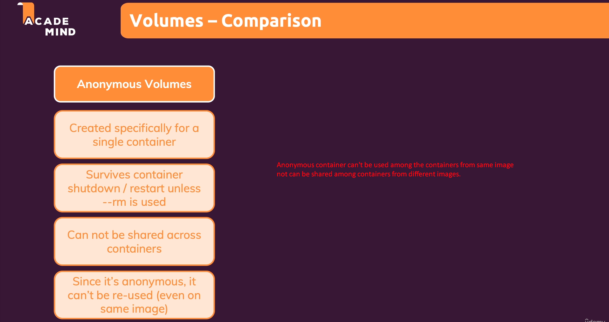
   2. **Named Volume**:
      1. Graphical user interface, text, application, chat or text message

         Description automatically generated
   3. **Bind Mount**:
      1. A picture containing diagram

         Description automatically generated
3. Brief Advantages of Volume:
   1. To share data among different containers.
   2. To improve efficiency of containers as we don’t need to put all data inside an image so inside a container.  
      So lightweight containers.
   3. To more changes in configuration, Js, HTML, CSS files very easily from outside on your local system.